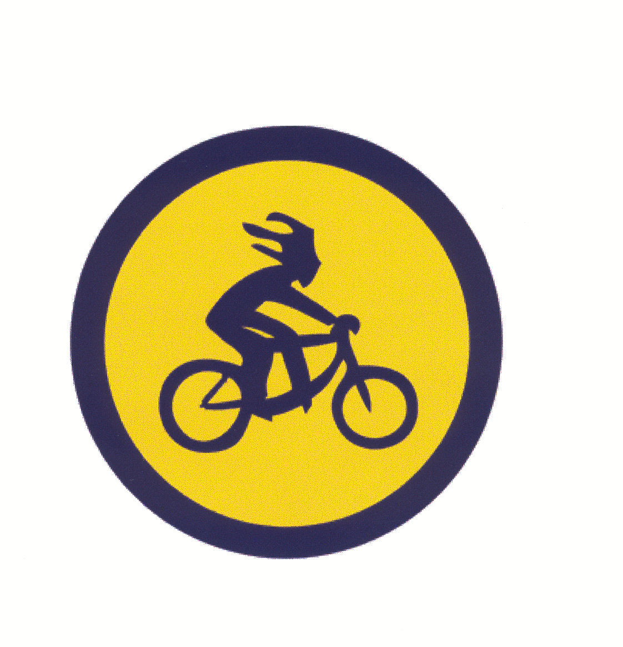
The
8 HOURS OF ROUND TOP
REGISTRATION FORM | July 23, 2005 9:00 AM to 5:00 PM  Round Top Park, Athens PA

Formerly the 12 Hours of RoundTop
This year’s race will follow the same format as the 12 Hours of RoundTop from the past 4 years. The course, atmosphere and quality of event will be held to the same high standards that have created such a successful endurance mountain biking race.

Categories:

Expert *Cash Prizes: SOLO (M/F) _______ 2-PERSON (M/F/MIX) ______

Sport: Traditional RT Prizes: SOLO (M/F) _____ 2-PERSON (M/F/MIX) _____ 3 or 4-PERSON____

TEAM NAME _______________________________________________________________

TEAM CAPTAIN ____________________________________________________________

ADDRESS ___________________________________________________________________

CITY ___________________________ STATE __________________ ZIP ______________

PHONE # _________________________ E-mail (optional) ___________________________

http://bikeroundtop.tripod.com
REGISTRATION FEE

solo …… $50.00 2-person …… $90.00 3 or 4-person ……$180.00
Make checks payable to 12 Hours of Round Top
Send registration to: 12 Hours of Round Top c/o John Heath
711 N. Wilbur Ave
Sayre, PA 18840

In consideration of all the acceptance of entry, I, intending to be legally bound, do hereby, for myself, my heirs, my executors, and administrators, waive and discharge any and all rights and claims which I may have, or which hereafter occur to me against Round Top Park, its affiliates and/or subsidiaries, any Race sponsors and their agents and employees, and all other persons or entities associated with this event from any claims I may have arising from this event, including personal injury or damage suffered by me or others while participating in and traveling to and from this event.

Signature of entrant (s) (signature of parent if participant is under 18)

X Date:

